Boat Archives - ‘Cylora’
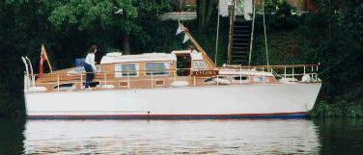

Do you know more about this boat? Tell us!

Length | 40’ | Prior Names | Hadar
Year Built | 1962 | Build No. | 40/15
Beam | 11’ | Hull Construction | Double diagonal teak
Draft | 3’10 | Deck Construction
Engine Make | Twin Ford Sutton, fitted 1999 | Superstructure Style
Engine Size | 80 HP each | Number of Berths
Engine Fuel Type | Diesel | Location | Severn Motor Yacht Club

History
 | Built for Mr Cyril Scott of Staines. (Chief of Smiths Crisps) to replace his 25' Star Craft. He may or may not still have owned a Bates Built slipper stern launch called CYLORA II.
 | Registered in Bristol in 1967.
 | Owned at some time by one George Knight.
1999 | Owned by Tony Jocelyn Butwell of Tewksbury.
 | See ELVESETER - 25'.
 | Certificate of British Reg. 333814
 | Original owner was a Mr Shirlan (?).

